Opiniano, Ezkylle 02/12/2026
NW – 301 6BLOCKTECH
Midterm Exam (LAB)
Code:
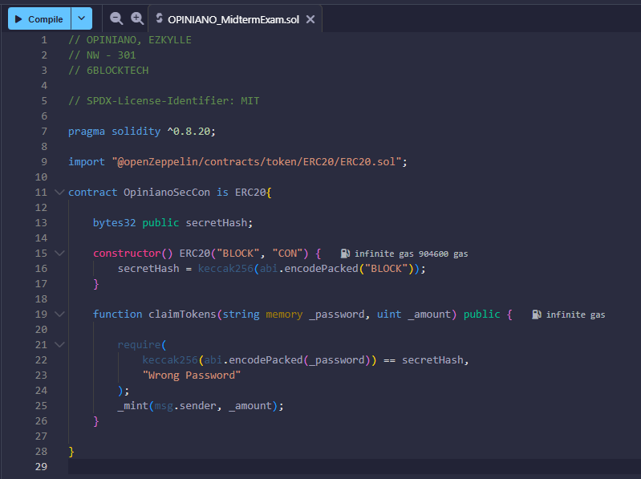
Wallet before deploying:
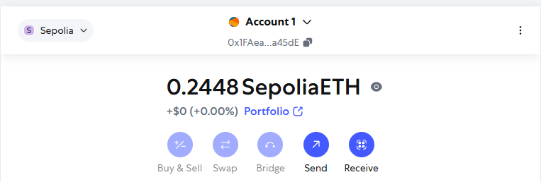
Wallet after deploying:
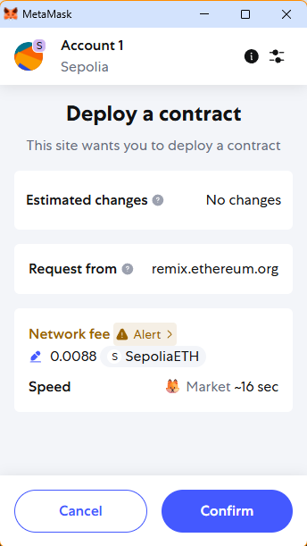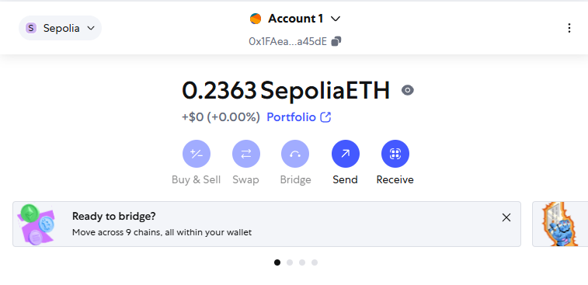
Screenshot of generated Keccak-256 hash of the word BLOCK
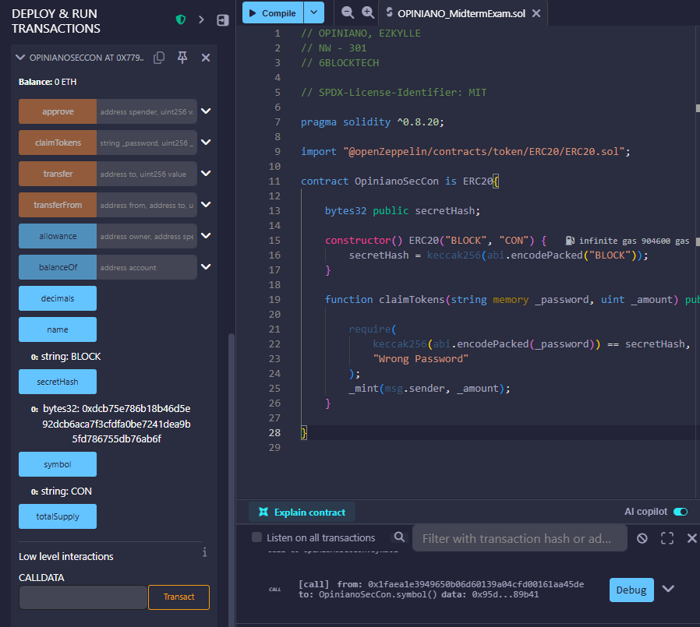
Screenshot of claiming the 100 tokens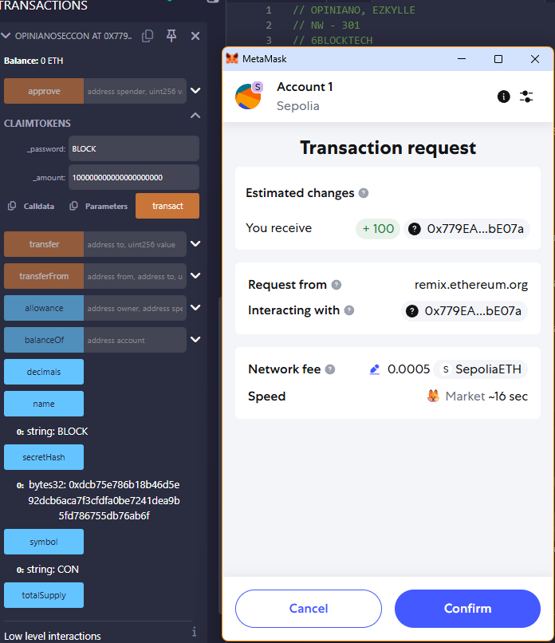

Before claiming of 100 tokens wallet balance: 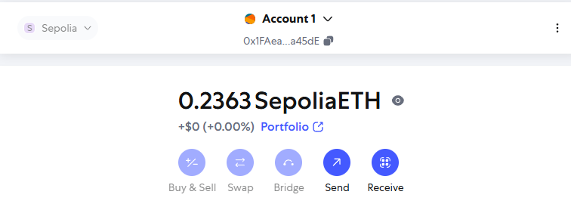
After claiming of 100 tokens wallet balance:
